LONG TERM RESEARCH PROGRAMME (2023-2028)
application form

Introduction

Information about the call for proposal, the requirements of the application, the instruction to fill in the forms and the submission of the application can be found in the Dutch document “Toelichting_voorwaarden en instructies call LLP 2023-2028” and the English version “Information_requirements and instructions call LTP 2023-2028” (https://reumanederland.nl/onderzoek/subsidiemogelijkheden-formulieren-procedure/).

Research plans for a LLP should be given in (relative) detail on the first half of the programme (July 2023-December 2025) and more globally on the second half of the programme (January 2026-June 2028).

1a - Applicant information

Institution

Department

Name of P.I.

Address

Zipcode/City

1b – Long term research programme title

1c – Kind of long term research programme, mainly
O Fundamental
O Translational
O Clinical

1d - Status of the long term research programme
O Continuation of an existing long term research programme.
Programme number: LLP-………

O Application for a new long term research programme
 | 1d - Project team
 | Please give the names of the people who are expected to be involved in the long term research programme between 2023-2028
Name (to be financed from budget) |  | Function | Organisation (name, department, address, city, country) | FTE
Name (not to be financed from budget) |  | Function | Organisation (name, department, address, city and country) | FTE
Support team |  | Function | Organisation (name, department, address, city and country) | FTE
 |  | Department secretary |  | -
 |  | Financial controller |  | -
 |  | Press officer |  | -
 |  |  |  | -
 |  |  |  | -

2a1 - Justification for request related to Dutch Arthritis Society
Please describe and explain your LLP fits with and contributes to one of both ambitions of the Dutch Arthritis Society (1. To turn arthritis into a non-chronic, reversable disease and 2. To develop precision (personalized) medicine for people with arthritis) and to minimal one theme which is part of that ambition(s).

Max. 1/2 page A4

2a2 – Justification for request based on expertise
Please describe results in the last five years, focus of research and reached goals. Next to this, describe in which way your research group is established and embedded in the research infrastructure of your institute.
Max. 2 pages A4

2b - General description of planned research focus

Please give a global description of the plans for your long term research programme in the period 2023-2028. Describe the originality of innovativeness of the proposal. What is new and unique?
Max. 1 page A4

2c - Overall long term vision and expectations for future research

Please explain what your expectations of the planned research are, e.g. what concrete, useable results do you expect within the next few years?
Max. 1 page A4

3 – Detailed research projects for the first half of the long term research programme (June 2023-December 2025)

Please explain the details of the research projects that are planned as part of the long term research programme. Describe the interdisciplinary, transdisciplinary and/or international collaboration per project.

Items 3a-3e can be duplicated as often as necessary. A maximum of 4 pages per project is allowed. However, more than 3-4 sub projects on a budget of 100k per year are not deemed logical or feasible considering the focus and concrete outcomes that we expect.
Max. 4 pages A4 per research project (items 3a-3e)

3a – Research project title

3b - General description of the research project

Please explain what research project you will conduct within the frame of the long term research programme.

3c - Financial information

Please give the amount or percentage of funding that will be used out of the long term research programme funding.

3d - (Inter)national networks and collaboration for this project

Please list the necessary or planned networks and collaborations (interdisciplinary, transdisciplinary and/or international collaboration).

3e - Work plan, milestones and timelines for the first 2,5 years for this project

Please explain in more detail your work plan, timelines and milestones for the next 2-3 years. Please mention criteria for go/no-go decisions that will be used to meet the timelines and milestones.

4 - General plans (January 2026-June 2028)

Please give the general plans for the rest of the long term research programme period.
Max. 2 pages A4

5 - Long term vision and expectations

Explain in what way, and when, the expected results of this long term research programme will be useable in clinical practice.

Describe the route, the factors that influence that process and which stakeholders have to be involved in that process and when in your impact pathway (fill in the questions in the attachment).

Explain how the research projects within the project contribute to this.

Next to this, explain what will be decided if the results are unexpected or negative.
Max. 1,5 pages A4.

6 - Expected amount and way of matching from university or other organisations

Please describe the amount of matching of the university and/or other organisations and the way the matching will be done. Please also explain whether additional funding is needed and where it will found.
Max. 1 page A4.

7 - Animal models & alternatives (if applicable)
Give the rationale for the use of animal models. Please state clearly why the proposed animal model(s) need to be used. Furthermore, explain what alternatives have been considered and why they can’t be used. Finally, explain whether you plan to develop alternatives for animals (or not). Included already obtained DEC approvals if available.
Max. 1 page A4

8 – Scientific summary of the long term research programme
Scientific summary of the proposal (introduction/hypothesis/workplan/expected results/conclusion). Next to this, the summary concerns the state-of-the-art of the work field, the reasons why the Dutch Arthritis Society should fund the proposal and the relevance for/input from patients/end users as well.

Max. 1 page A4 (no tables/figures allowed).

Attachment. Impact pathway plan of action
Step 1. From problem to impact
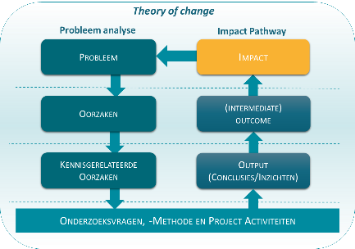
- Describe the desired social impact for the problem described in the application: what is the intended social change.

- Describe the social players and factors that determine the context: which actors and which (lack of) resources are crucial for success?

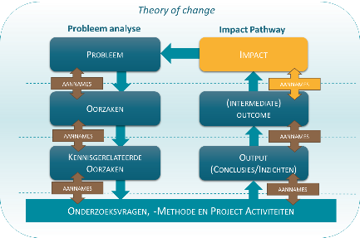

- What assumptions are made when formulating the desired social impact?

Step 2 Outcomes: Who needs to change what?
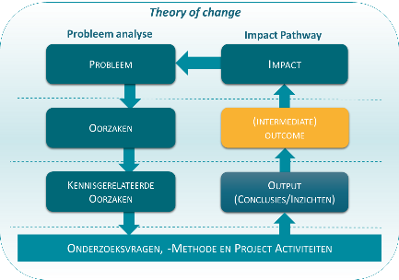
- Which stakeholders play a role and which changes are needed?

- Formulate concrete outcomes: who should do what differently to achieve the intended impact?

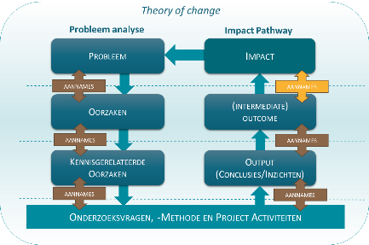
- Which assumptions apply to the outcomes and to the step from outcomes to impact?

Step 3 Output: needed insight from the project
- Formulate output: what insights are needed to realize the desired outcomes

- Which assumptions apply to the output and the step from output to outcomes?

Step 4 Indicators for the impact pathway
- Formulate for each output an indicator

Output: | Indicator:

- Formulate for each outcome an indicator
Outcome: | Indicator:

